RSign for Eclipse by NasaSoft Admin Guide

Overview
RSign integration with Eclipse allows Admins to set up user accounts for sending Acord Forms for e-signature directly from the Eclipse interface.
The setup is only required one time for the agency. The setup is agency-specific and will only be needed in the main agency in a multi-agency setup. Each agency can have its own unique Reference Key, or the same Reference Key can be used for all agencies. Only agencies setup with a Reference Key will be able to use RSign.
Note: the RSign integration with Eclipse can only be setup by an Eclipse System Administrator. If you don’t have your Reference Key, please contact your RSign representative to request it.

How to set up RSign:
- On the Menu Bar, click Setup, Vendor Integration Setup and RSign Setup.
- The RSign Setup window displays.
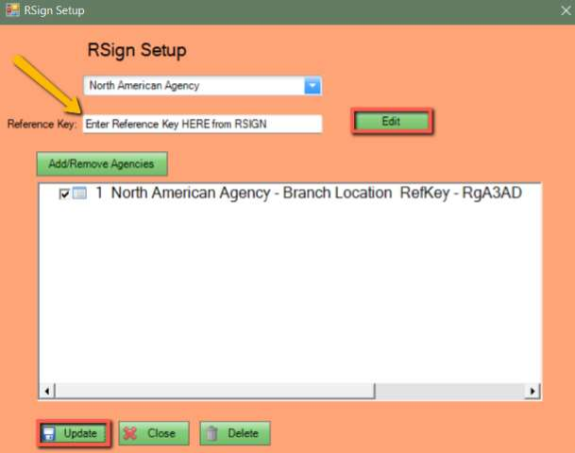
- Select the Agency from the drop down listed at the top that is setting up RSign. If setting up more than one agency with the same reference key, select the main agency from the list.
- Click “Edit”.
- Enter the Reference Key to the left of the Edit button – This Reference Key must be obtained from RSign when signing up for their services; contact your RSign representative if you do not have it.
- Click ‘Add/Remove Agencies’ if setting up more than one agency.
- Place a checkmark in the agencies that will be using the same Reference Key for RSign services.
- Click Update.
Note: Agencies in the same Eclipse database may use different Reference Keys if they already are an RSign customer. Repeat each step from “Select the agency from the dropdown…” for each unique Reference Key.
- Once the necessary setup has been completed, click Update and Close.
- That’s it! The integration is now ready to be used by your end users.

